FastTrak Software Publishing
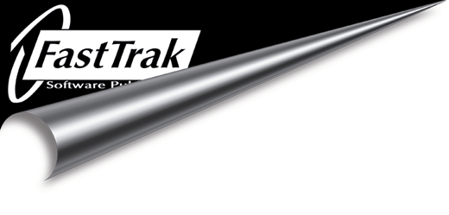

Home and Garden Essential Selection Upgrade Information
and Complete Product Listing
May 2000

Thank You for buying Home and Garden Essential Selection from FastTrak Software. As you can see from the product list below, Home and Garden Essential Selection is part of a range of software products published by FastTrak.

You can upgrade to either one of the Deluxe titles, for the special Essential Selection price of £9.99. If you decide to upgrade BOTH titles, you will be given the special price of £15.00.

Alternatively you can upgrade to one of the Professional Titles for the special essential selection price of £19.99 or upgrade to both Professional Titles for £35.00. (NB: Please note file types of Home & Garden Essential Selection are not compatible with the Professional Titles).

To upgrade simply call us on (++44) 01923 495496 quoting offer ref: HGES2000

Below we list other software titles available from our range.

Home & Garden - for PC only (Win 95/98) RRP

Visual Home Professional £29.99
3D Landscape Professional £29.99
Visual Home Deluxe £14.99
3D Landscape 2 Deluxe (with free Garden Encyclopaedia 2 Deluxe) £14.99
Home & Garden Essential Selection £19.99
Encyclopaedia Botanica PLUS £29.99

---------------------------------------------------
eJay Music Software - for PC only (Win95/98)

Dance eJay Megapack £14.99
Rave eJay Megapack £14.99
Hip Hop eJay Megapack £14.99
Dance eJay 2 £29.99
Dance eJay 2: Techno Edition £24.99
Sound Collection Volume 1 £19.99
Sound Collection Volume 2 £19.99
EJay MP3 Station £29.99

---------------------------------------------------

Games Software (Win 95/98)

DIV Games Studio £34.99

---------------------------------------------------

Digifun – Hobby Software for PC only (Win 95/98)

Stitch Designer £14.99
Paint by Numbers £14.99
Puzzle Madness £14.99

All prices include VAT, but exclude delivery
Please note all prices are current at the time of going to press.

For more information, please call:
+44 (0)1923 495496
email:
fasttrak.info@polaron-group.co.uk

website:
http://www.fasttrak.co.uk

To order direct from FastTrak Software, please print out this form,
and either fax it to us on:
+44 (0)1923 228 796,
or post it to:
FastTrak Software Publishing,
26 Greenhill Crescent,
Watford,
Hertfordshire,
WD1 8XG,
United Kingdom

